Support Vector Machine Model(regression):

Data set information:

The dataset utilized in this project is [California Housing Prices]. The total number of samples in the dataset is [20640] For the training, and testing phases, [1840] samples are allocated for training, [15480] for validation, and [5160] for testing.

Feature Extraction Phase:

1. Number of Features Extracted: After preprocessing, feature engineering, and encoding categorical variables, the dataset contains 13 features.

2. Feature Names: The extracted features are:

- Longitude

- Latitude

- Housing Median Age

- Total Rooms

- Total Bedrooms

- Population

- Households

- Median Income

- median house value

- Ocean Proximity

- Rooms per Household

- Bedrooms per Room

- Population per Household

3. Dimension of Resulted Features: The dimension of the dataset after feature extraction is (x, 13), where 'x' represents the number of samples.

Cross-Validation:

Cross-validation is used in the Support Vector Regression (SVR) model for model evaluation. The cross_val_score function with 5-fold cross-validation is employed to generate cross-validated estimates for each input data point. The training data is split into 5 folds, and the model is trained and evaluated 5 times, using a different fold for evaluation each time.

Hyperparameters:

The hyperparameters used in the SVR model are as follows:

- degree: The degree of the polynomial kernel function. It's set to 2.

- C: Penalty parameter of the error term. It's tuned using grid search with values [1, 10, 50, 100].

- kernel: The kernel function used in the algorithm. It's set to 'linear'.

Plots:

Collaboration curve:

Mean Squared Error curve:

Decision tree Model:

Data set information:

The dataset utilized in this project is [loan approval]. The total number of samples in the dataset is [4269] For the training, and testing phases, [1840] samples are allocated for training, [15480] for validation, and [5160] for testing.

Feature Extraction Phase:

1. Number of Features Extracted: The dataset consists of 11 features.

2. Feature Names: The extracted features are:

- NO Of Dependents

- Income Annum

- Loan Amount

- Loan Term

- Cibil Score

- Residential Assets Value

- Commercial Assets Value

- Luxury Assets Value

- Bank Asset Value

- Education

- Self Employed

3. Dimension of Resulted Features: The dimension of the dataset after feature extraction is (100, 11), where 100 represents the number of samples and 11 represents the number of features.

Cross-Validation:

Cross-validation is used in the Decision Tree Classifier model for model evaluation. The cross_val_predict function with 5-fold cross-validation is employed to generate cross-validated estimates for each input data point. The training data is split into 5 folds, and the model is trained and evaluated 5 times, using a different fold for evaluation each time.

Hyperparameters:

The hyperparameters used in the Decision Tree Classifier model are as follows:

- criterion: The function to measure the quality of a split. The default is 'gini', but in this case, it's not specified, so it's 'gini' by default.

- splitter: The strategy used to choose the split at each node. The default is 'best', but in this case, it's not specified, so it's 'best' by default.

- max_depth: The maximum depth of the tree. It's not specified, so it grows until all leaves are pure or until all leaves contain less than min_samples_split samples.

- min_samples_split: The minimum number of samples required to split an internal node. It's not specified, so it's 2 by default.

- min_samples_leaf: The minimum number of samples required to be at a leaf node. It's not specified, so it's 1 by default.

- random_state: The seed used by the random number generator. It's specified as 42 to ensure reproducibility.

Plots:

Confusion matrix:

Roc:

Decision tree visualization:

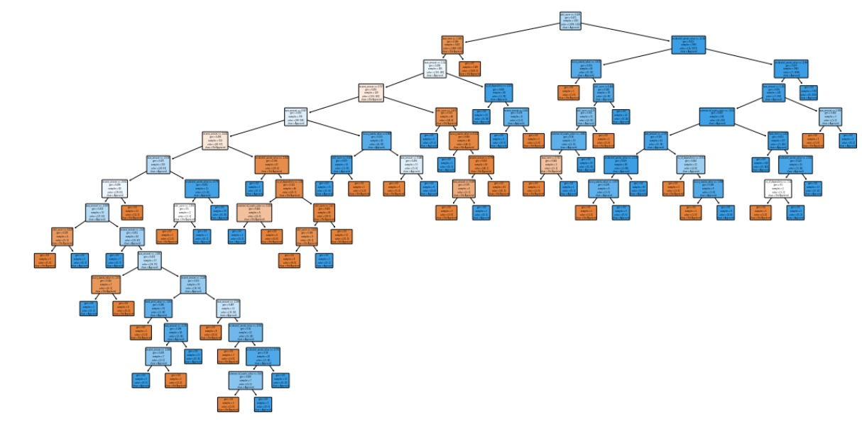

Neural network Model:

Data set information:

The dataset utilized in this project is [natural images]. It comprises [8] classes, with their corresponding labels being ['motorbike', 'airplane', 'flower', 'dog', 'fruit', 'car', 'cat', 'person']. The total number of samples in the dataset is [6899] each of size [56x56 pixels]For the training, validation, and testing phases, [5519] samples are allocated for training, and [1380] for testing.

Feature Extraction Phase:

1- Number of Features Extracted*: In the feature extraction phase, the images are resized to 56x56 pixels, resulting in a total of 56 * 56 = 3136 features per image.

2 -Names of Features: Each pixel value in the resized image can be considered as a feature. Since the images are grayscale, there is only one channel (intensity) per pixel.

- Dimension of Resulted Features: After flattening the resized images, the dimension of the resulted features is (56 * 56) = 3136.

Cross-validation Usage:

Cross-validation is used in the implemented model. Specifically, the model.fit() function includes a parameter validation_split=0.2, which indicates that 20% of the training data is used as validation data during training. This technique splits the training data into training and validation sets internally.

Hyperparameters Used:

- Initial Learning Rate*: The initial learning rate used is 0.0001.

- Optimizer*: Adam optimizer is used with the specified learning rate.

- Loss Function*: Sparse categorical cross-entropy loss function is used.

- Metrics*: Accuracy is used as the evaluation metric.

- Batch Size*: The batch size is not explicitly specified in the provided code. It defaults to the value set by the Keras framework.

- Number of Epochs*: The model is trained for 20 epochs, as specified in model.fit().

Plots:

Accuracy curve, loss curve:

Confusion matrix:

ROC curve:

